# **Principle Source of Optimization**

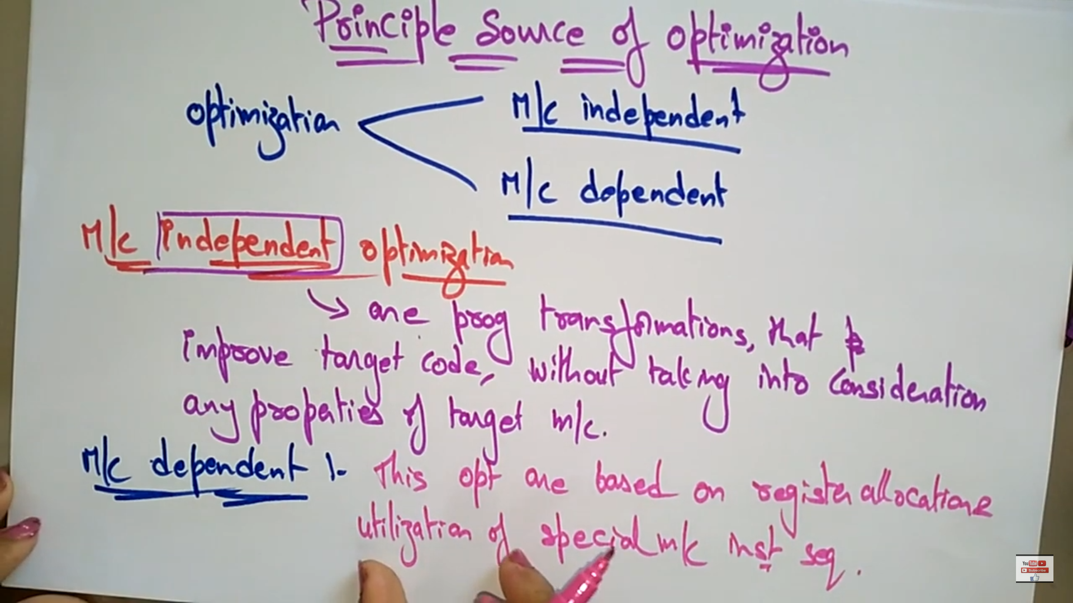

# **Code Optimization Techniques**

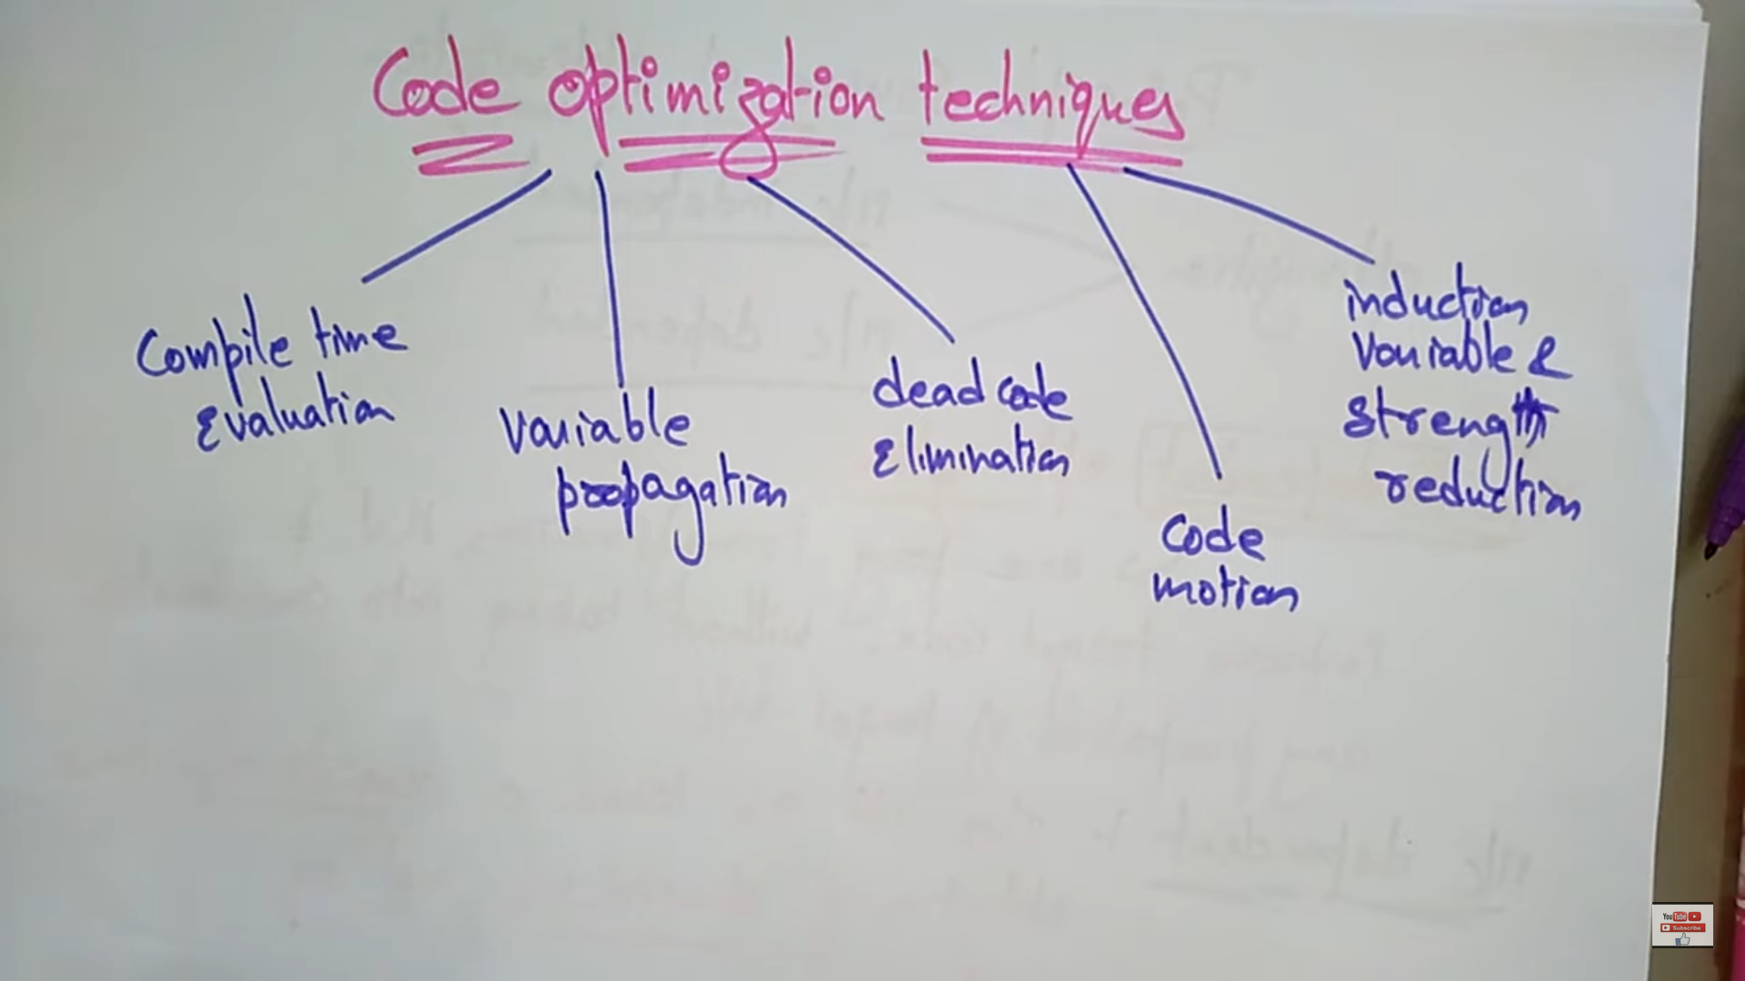

## **Compile Time Evaluation**

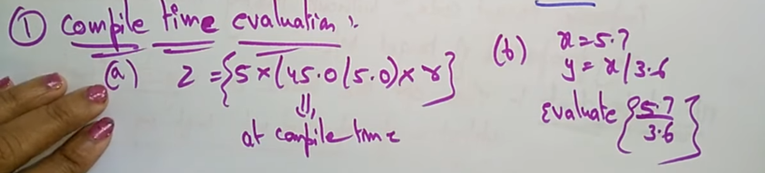

## **Variable Propagation**

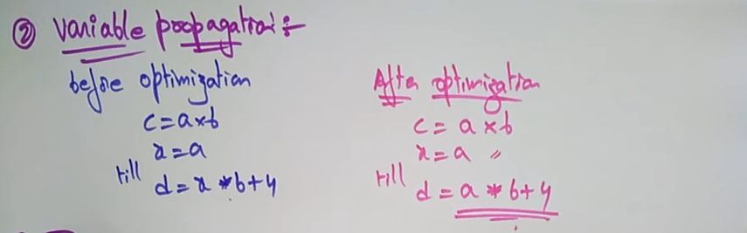

## **Dead Code Elimination**

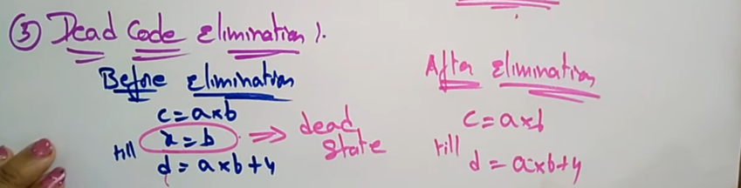

## **Code Motion**

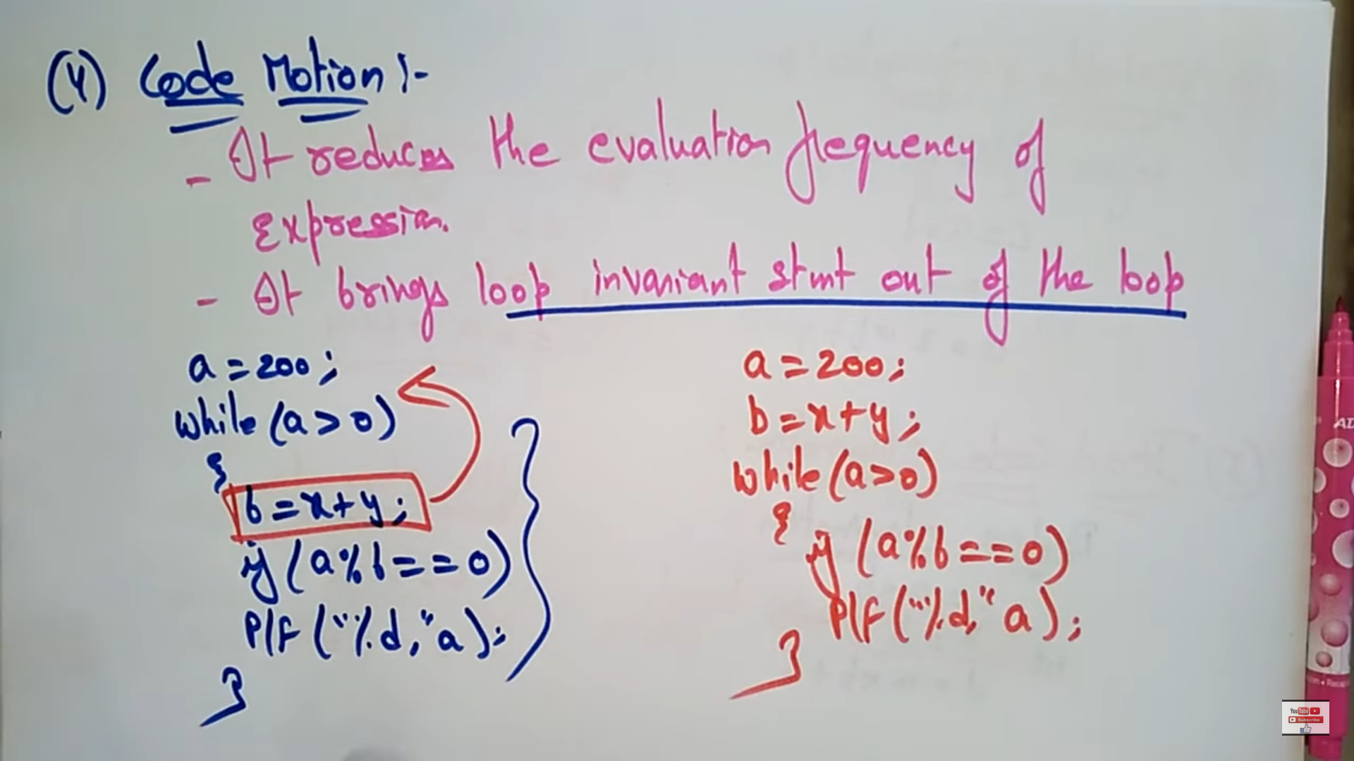

b=x + y 🡪 is not at-all necessary in the loop, so they can be removed from the loop.

## **Induction variable and Strength Reduction**

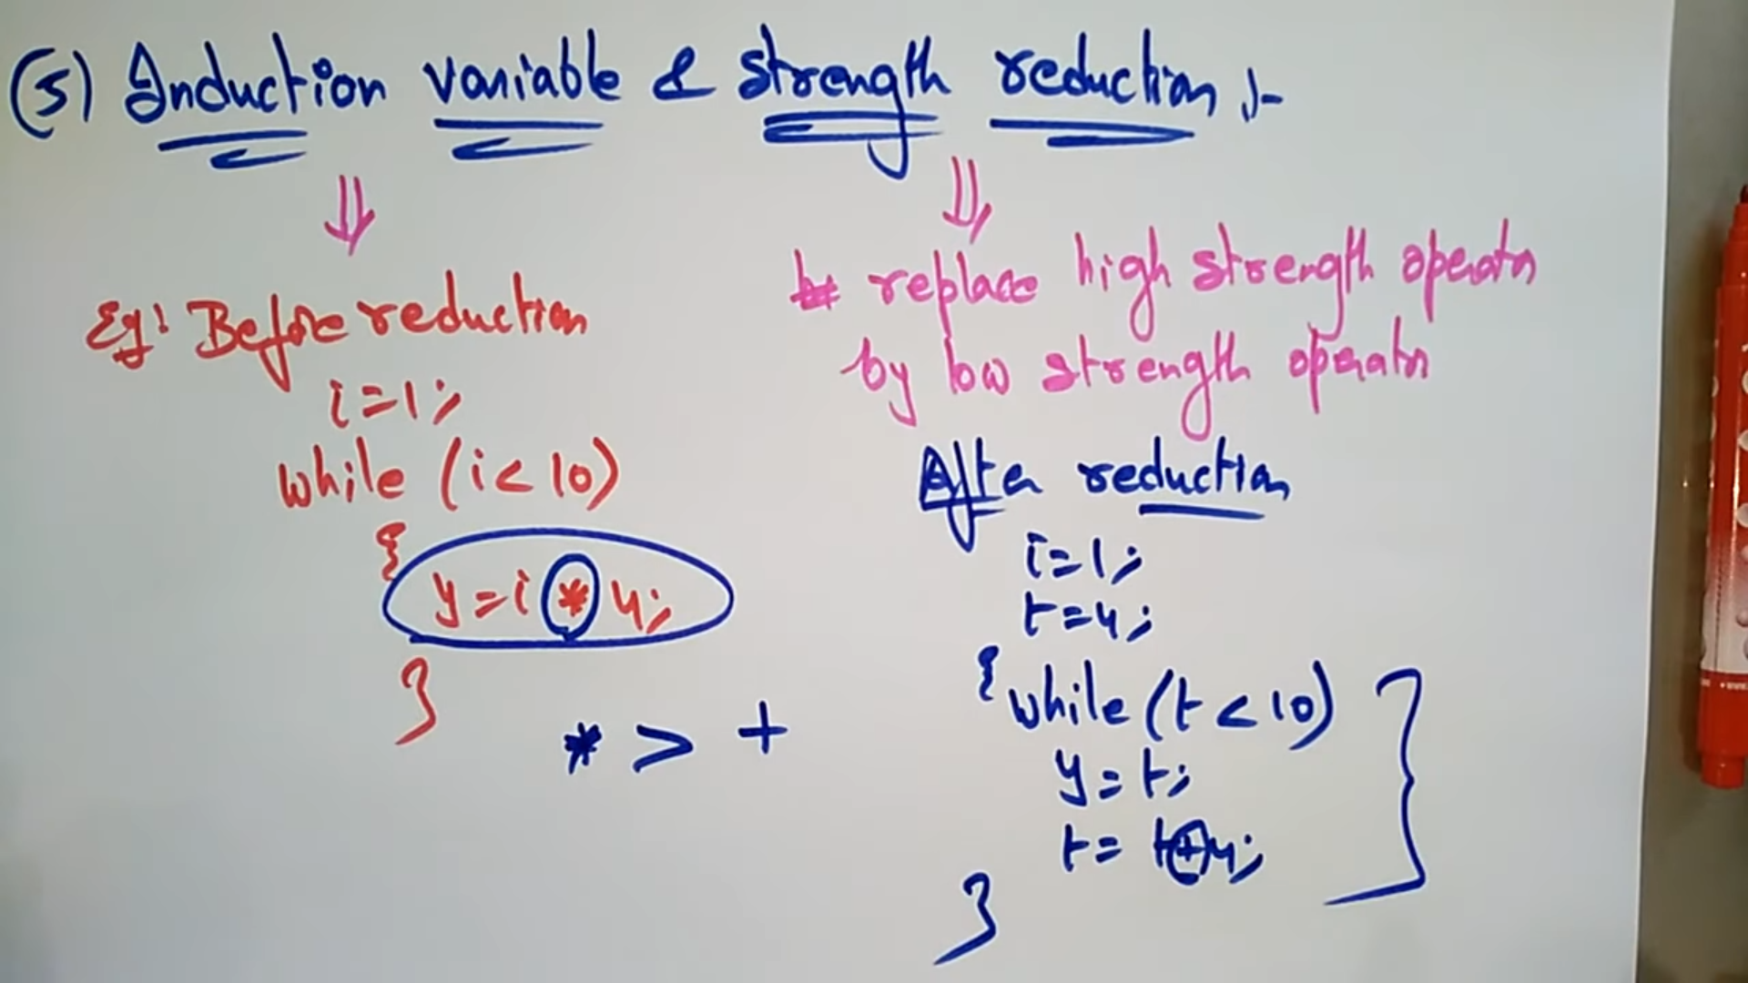

Product is replaced with + 🡪 strength is reduced

# **Loop Optimization Techniques**

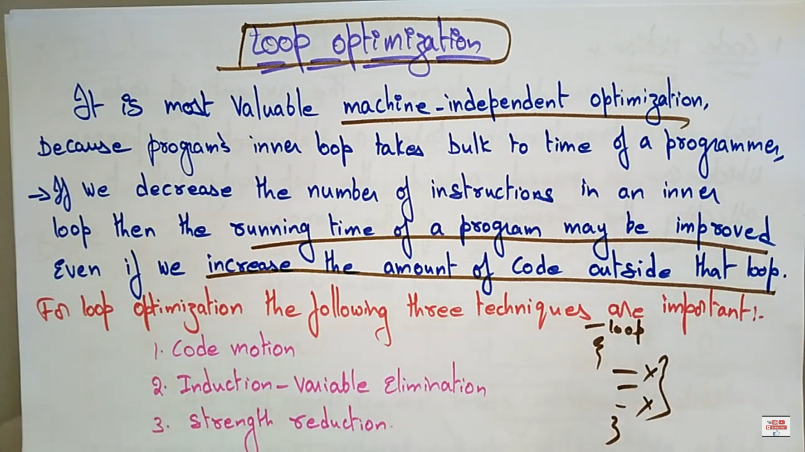

We can optimize by removing the unwanted statements and placing outside the loop.

## **Code Motion**

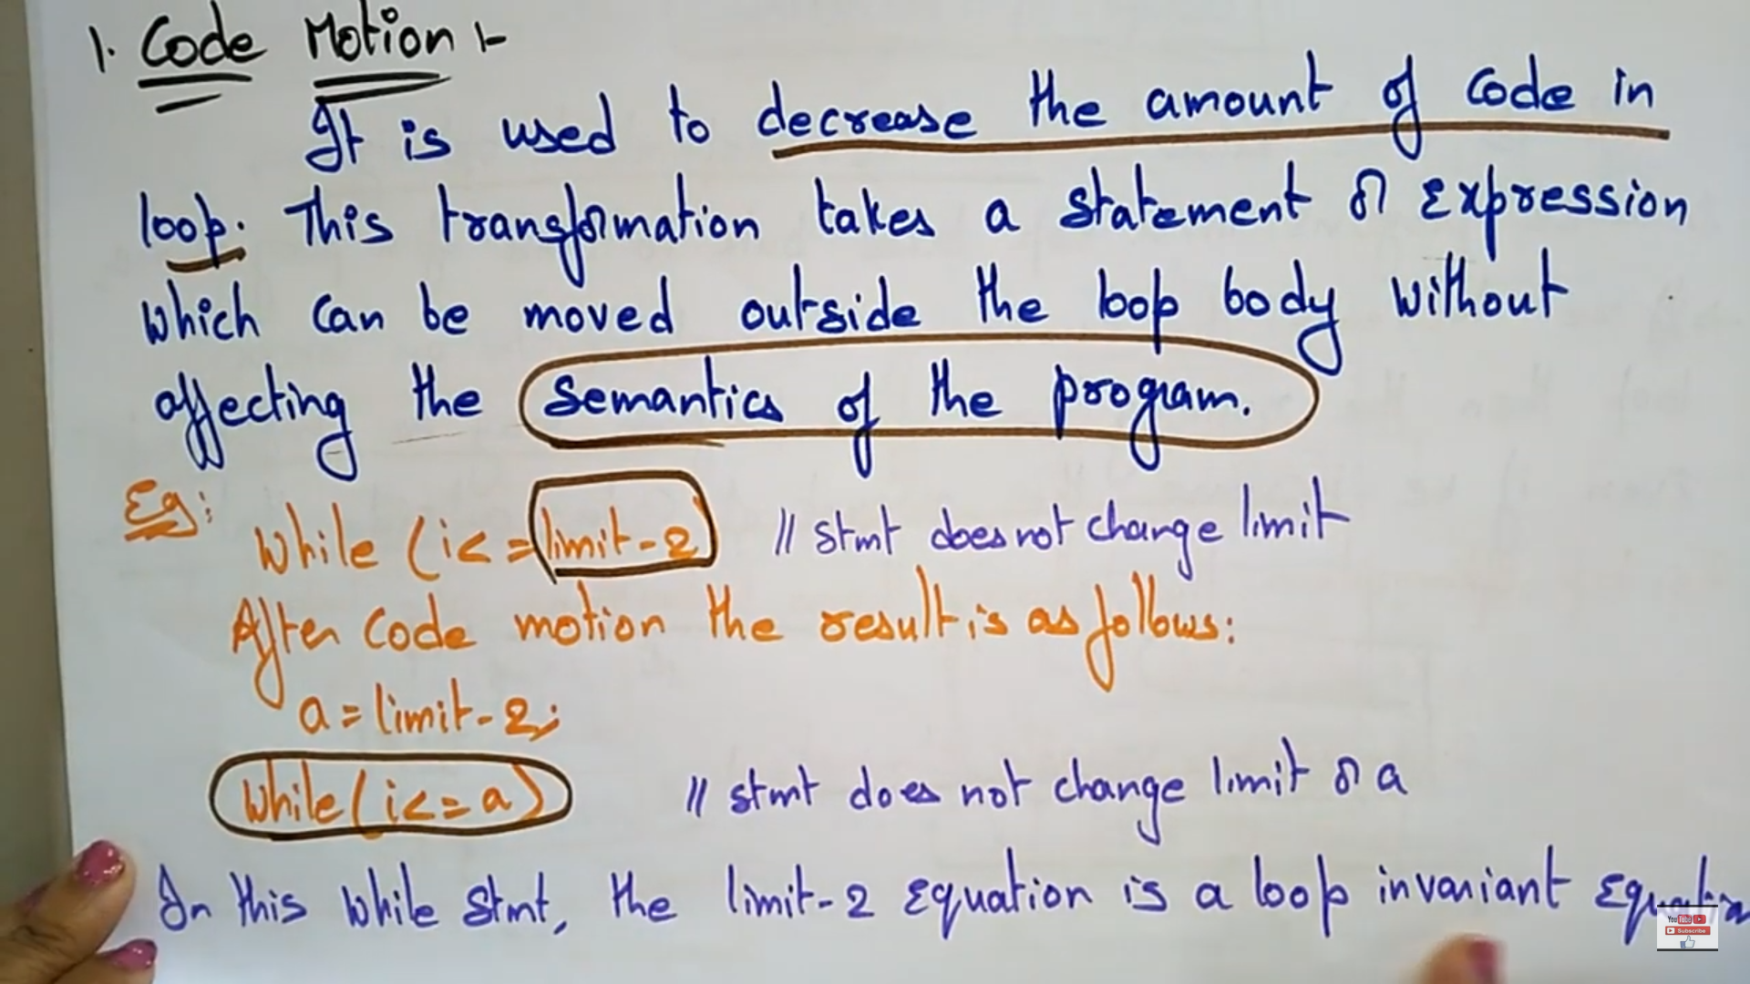

## **Induction Variable Elimination**

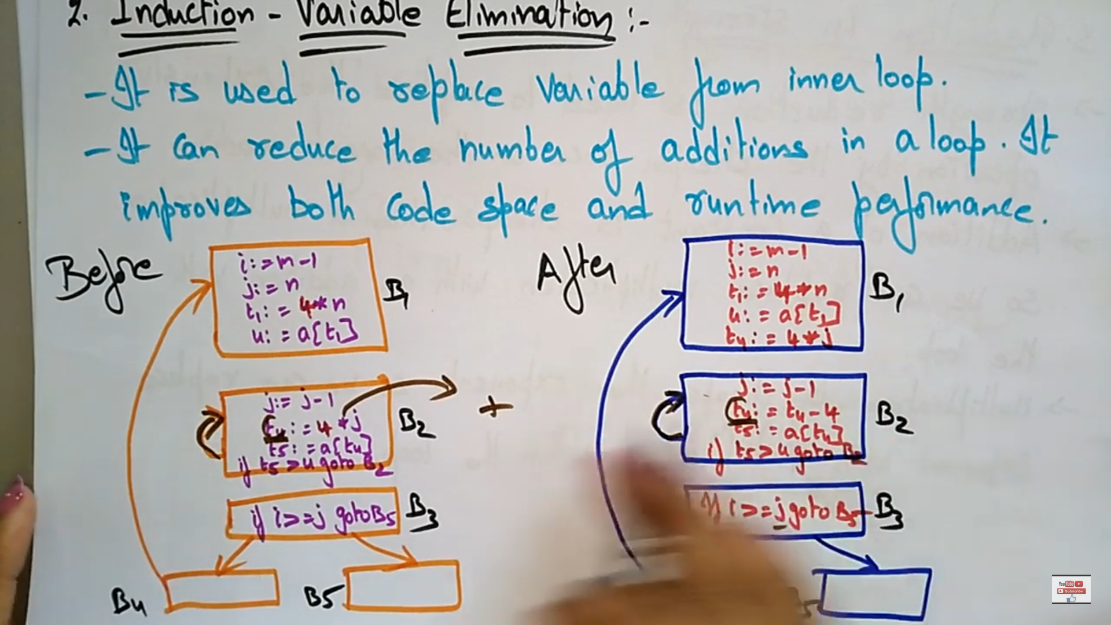

## **Reduction in Strength**

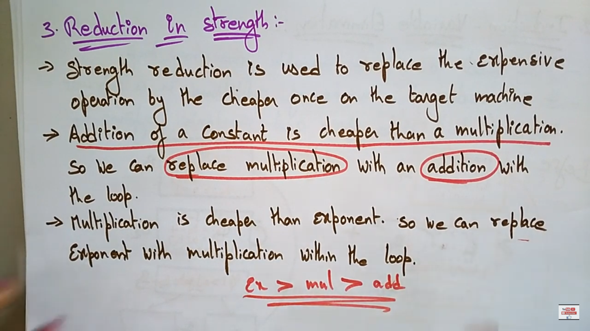

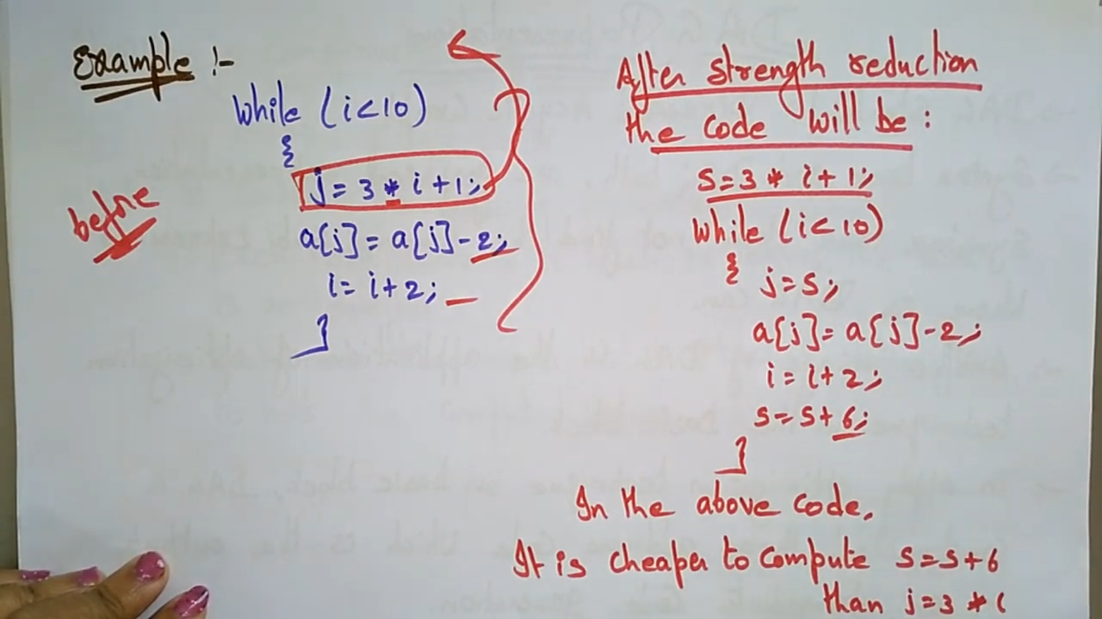



# **Introduction to Data Flow Analysis**

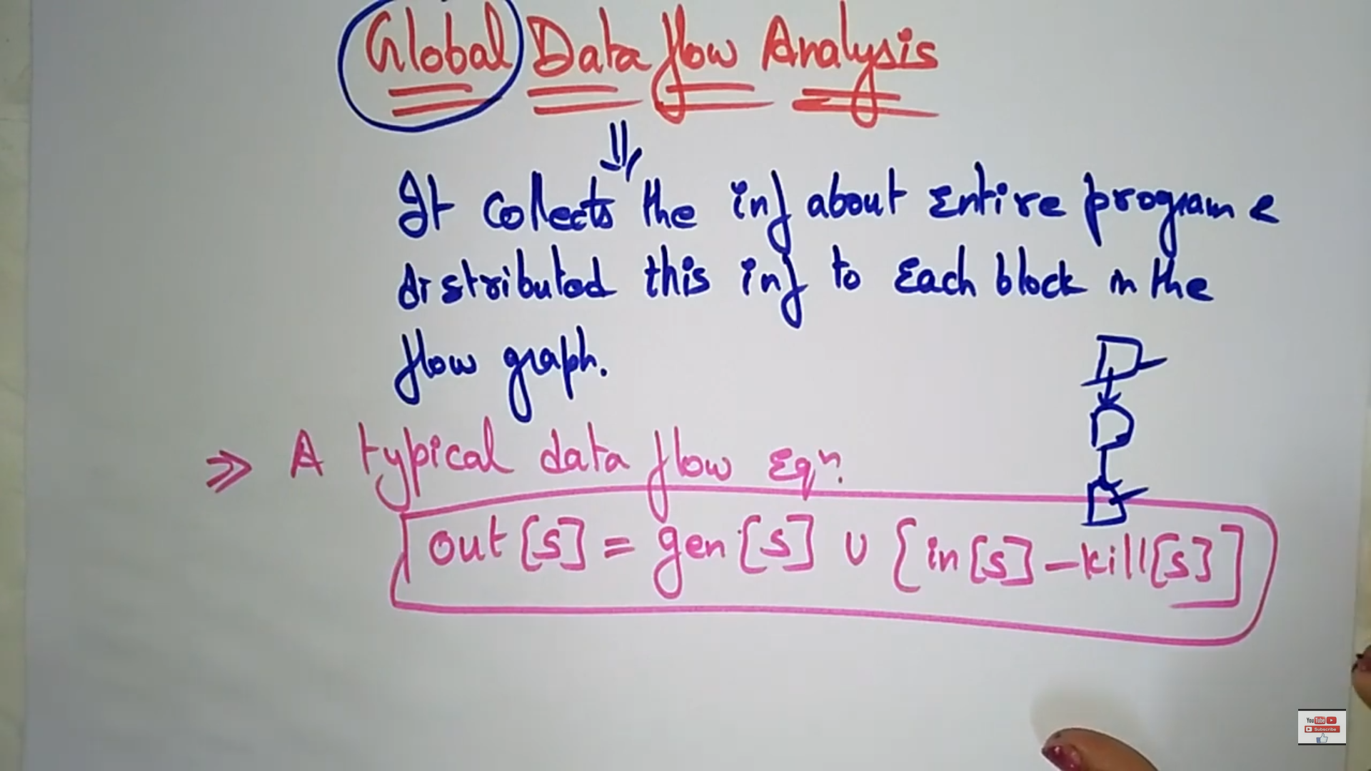

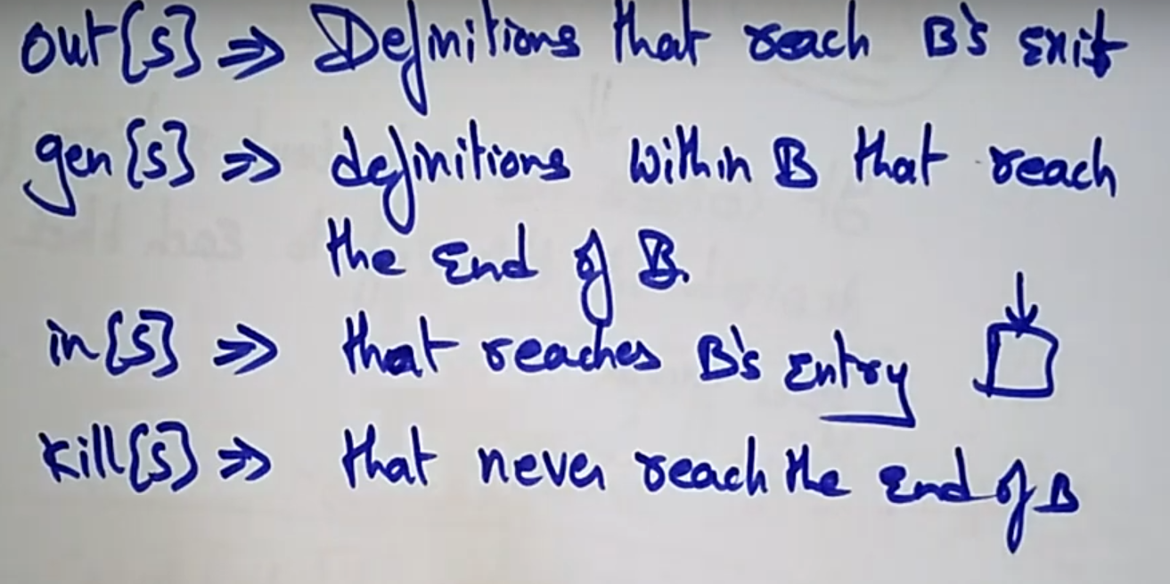

# **DAG (Directed Acyclic Graph)**

